**Transmission Line Subconductor Design**



**Javier Jesús Macossay-Hernández**

**EE443 – Introduction to Power Systems**

**University of Southern California**

**Professor Robert Castro**

**Objective**

In power engineering, it is necessary to compare different transmission line models offered by the vendors and compare the own designs of the transmission lines. After comparing all alternatives, the engineering design and implementation team will need to choose the best option of conductor type to fulfill the requirements and needs of the company.

**Introduction**

A system with a load connected to it is upgraded with a new substation. This new substation will have its energy supplied by another nearby substation. Nonetheless, engineers must choose what type of conductor to use; additionally, engineers must select if a single conductor or a subconductor bundle of two or three subconductors. In this problem, these alternatives will be explored using PowerWorld and evaluated according to the most suitable option.

**Methods**

In this problem, we will make the assumption that we have only three conductors: Ostrich, Cardinal, Bluejay. The steps to complete this problem are the following:

1. The original model and the modified model of this problem will be explained.
2. Realize the type of conductor bundle transmission line needed to support the new load.
3. Calculate the GMD of the selected subconductor bundle.
4. Calculate the transmission line parameters for Ostrich, Cardinal, and Bluejay conductor and simulate it in PowerWorld.
5. Compare and analyze the three transmission line options and choose the best option.

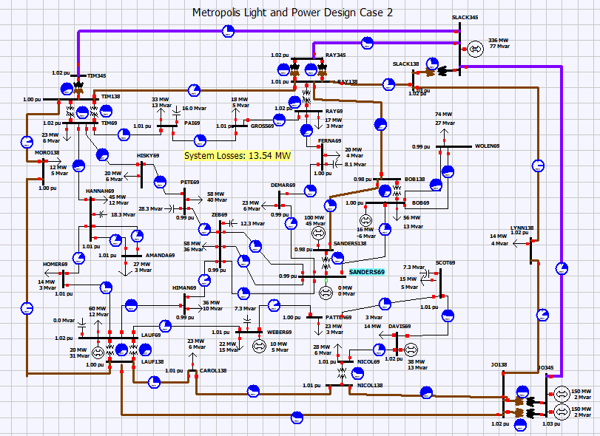

Figure 1: Original Model

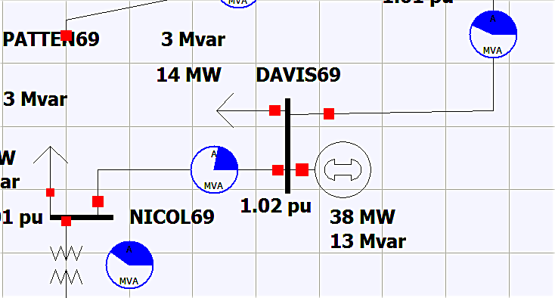

Figure 2: Bus DAVIS69 before modification

The original model had two transmission lines to bus DAVIS69 from bus NICOL69 and bus SCOTT 69. In addition, it has a load of 14MW and 3 MVAR and a de-energized generator.

The new substation LUPITA69 is connected to a load of 125.54 MVA (116 MW and 48 MVAR)

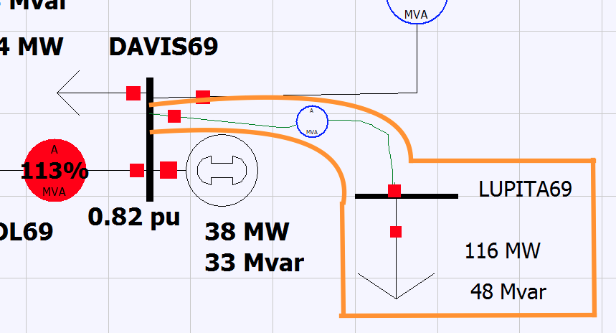

Figure 3: New Substation Bus LUPITA69

Because the new substation load is higher than usual, the generator at bus DAVIS69 is de-energized and must be energized. It must be done in order to avoid the overloading of the bus, supply the new load demand, and maintain the voltage profile and power factor.

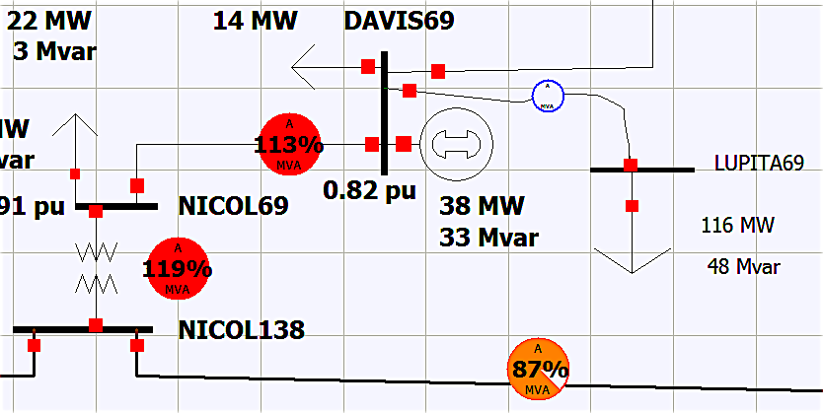

Figure 4: Transmission Lines Supplying Bus DAVIS69 Overloading

The modified model now has a 69 kV bus LUPITA69 with a connected load of 125.54 MVA, 116 MW, and 48 MVAR.

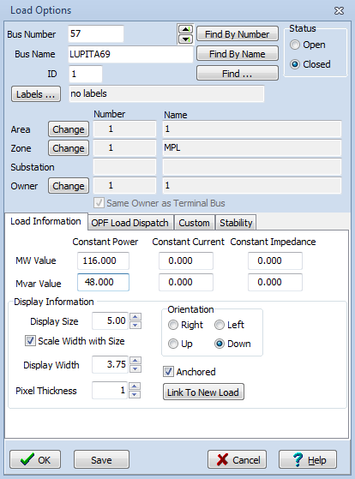

Figure 5: Bus LUPITA69 Load Information

The generation unit is a gas combustion turbine (CT) with 160 MW with the reactive power limited to 30 MVAR for control purposes.

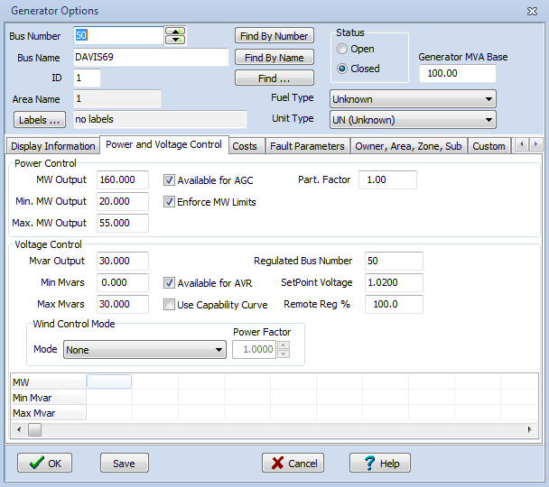

Figure 6: Bus DAVIS69 Generation Unit Information

**Calculations**

The following values will be kept constant across the following discussion:

MVA = 125.54 MVA

V = 69 MVA

MVA= √3 VLL I

I = MVA/ VLL= = 1050.44 A

The current rating for the subconductor bundles of one are given below:

Ostrich: 492 A

Cardinal: 996 A

Bluejay: 1092 A

Under these conditions, only the Bluejay conductor can handle the load, but it cannot accommodate for further load demand increases. As a result, the transmission line must be built with subconductor bundles of two or three.

A subconductor bundle of two will double the current rating.

Ostrich: 984 A

Cardinal: 1992 A

Bluejay: 2184 A

A subconductor bundle of three will triple the current rating.

Ostrich: 1476 A

Cardinal: 2988 A

Bluejay: 3276 A

With this modification (subconductor bundle of three), all conductors will handle the load, yet they will do so in different ways. In the following steps, the transmission line parameters will be found and, next, they will be modeled to find the loading and power losses to select the best transmission line.

Assume the below transmission line configuration with a line length of 20 miles.

d = 0.6’ D = 20’

Distance between each conductor d= 0.6’

Distance between each subconductor bundle phase D= 20’

To find the transmission line parameters, the geometric mean diameter (GMD) of the whole system must be found.

GMD = (multiplication of distances between bundles) 1/n, where n = number of bundles

Because there are three phases, then:

GMD = (D * D * 2D)1/3 = (20 * 20 * 40)1/3 = 25.2’

To convert to inches, multiply the value in feet by 12, so that:

GMD = 25.2’ *12 = 302.4”

*Ostrich*

Using table A3, DS can be found for each conductor to calculate the geometric mean radius for each subconductor bundle.

DS Ostrich = 0.0229’

GMRø = (DS x d x d )n/ (n^2) where n= number of conductors in each bundle.

GMRø = (0.0229 x 0.6 x 0.6)3/9 = 0.202’/ phase

With GMD and GMRø, L, C, XL, XC, R, Z, and Y can be found.

L = 0.7411 log (GMD/GMRø) mH/mile = 0.7411 log (25.2/0.202) mH/mile

L= 1.55 mH/ mi

C= 0.0388/ (log (GMD/ GMRø)) µF - mile = 0.0388/ (log (25.2/0.202)) µF - mile

C= 0.01851 µF – mi

XL = 2πƒ x L = 2π * (60) * (0.00155)

XL = 0.58 Ω / mi

XC = 1/ (2πƒ x C) = 1/ (2π * (60) * (0.00000001851))

XC = 0.143305 MΩ / mi

Because the line length is 20 miles, then the following are true:

XL = 0.58 x 20 miles= 11.6 Ω

XC = 0.143305M x 20 miles = 2.8661 MΩ

Y = G + j B

Assuming that the shunt conductance, G, is zero, then:

Y= j B

Therefore,

Y= 1/ (XC)

Y= 6.97812 µmho/ mi

R can be found from table A3:

R = 0.3070 Ω/mi at 20ºC for one conductor

Because the sub-conductor bundles have three conductors, the total resistance is reduced as their resistance is paralleled.

R= (1/0.3070 + 1/0.3070 + 1/0.3070)-1 = 0.1023 Ω/mi

Because the line length is 20 miles, then:

R= 0.1023 * 20 miles = 2.046 Ω

PowerWorld allows users to enter the parameters of the transmission lines in actual values and performs per unit conversions using user-defined base values. In this case, the base values are 100 MVA and a base voltage of 69 kV.

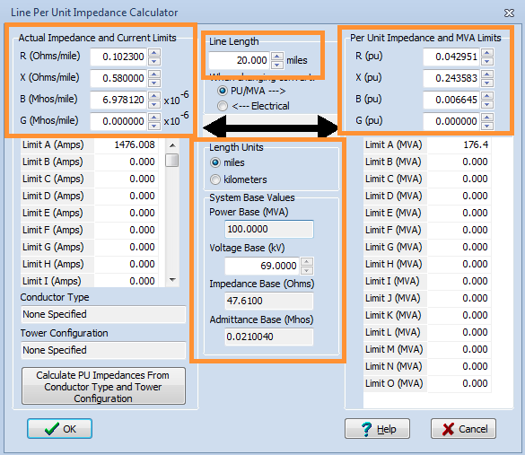

Figure 7: Impedance Conversion Values

MVA limits for this line must be found.

MVA = VLL I = * (69,000)* 1476 A

MVA = 176.4 MVA

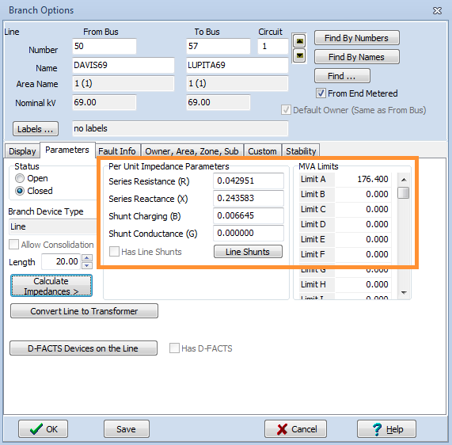

Figure 8: Parameters to Model a Subconductor Bundle of Three Ostrich Type Conductor Transmission Line

By running the model, power flow values and the power losses for the transmission line can be found.

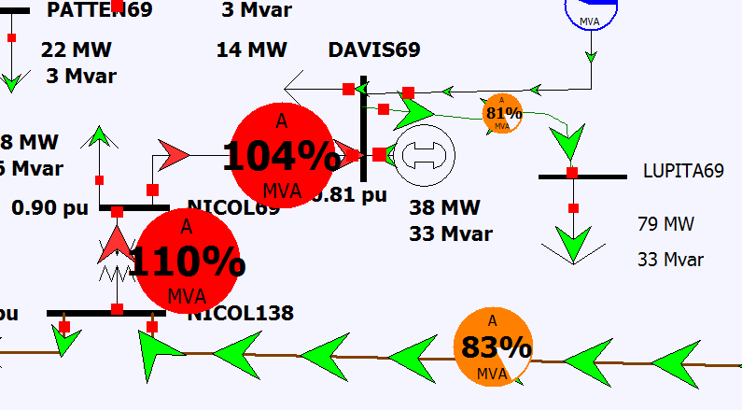

Figure 9: Model for Ostrich Transmission Line

As the model runs, a double click on the new transmission line will display the power flow and losses.

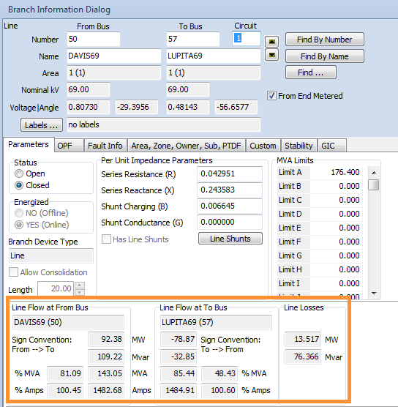

Figure 10: Ostrich Transmission Line Information

*Cardinal*

Using table A3, DS can be found for each conductor to calculate the geometric mean radius for each subconductor bundle.

DS Cardinal = 0.0402’

GMRø = (DS x d x d)n/ (n^2) where n= number of conductors in each bundle.

GMRø = (0.0402 x 0.6 x 0.6)3/9 = 0.244’/ phase

With GMD and GMRø, L, C, XL, XC, R, Z, and Y can be found.

L = 0.7411 log (GMD/GMRø) mH/mile = 0.7411 log (25.2/0.244) mH/mile

L= 1.49 mH/ mi

C= 0.0388/ (log (GMD/ GMRø)) µF - mile = 0.0388/ (log (25.2/0.244)) µF - mile

C= 0.01927 µF – mi

XL = 2πƒ x L = 2 π * (60) * (0.00149)

XL = 0.56 Ω / mi

XC = 1/ (2πƒ x C) = 1/ (2π * (60) * (0.00000001927))

XC = 0.137653 MΩ / mi

Because the line length is YYYY miles, then the following are true:

XL = 0.56 x 20 miles= 11.2 Ω

XC = 0.137653M x 20 miles = 2.75306 MΩ

Y = G + j B

Assuming that the shunt conductance, G, is zero, then:

Y= j B

Therefore,

Y= 1/ (XC)

Y= 7.26464 µmho/ mi

R can be found from table A3:

R = 0.0988 Ω/mi at 20ºC for one conductor

Because the sub-conductor bundles have three conductors, the total resistance is reduced as their resistance is paralleled.

R= (1/0.0988+ 1/0.0988 + 1/0.0988)-1 = 0.0329 Ω/mi

Because the line length is 20 miles, then:

R= 0.0329 * 20 miles = 0.658 Ω

PowerWorld allows users to enter the parameters in actual values and performs per unit conversions using user-defined base values. In this case, the base values are 100 MVA and a base voltage of 69 kV

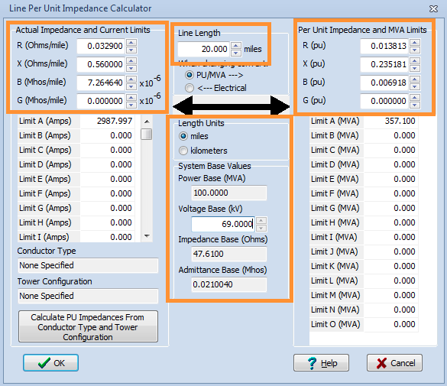

Figure 11: Impedance Conversion Values

MVA limits for this line must be found.

MVA = VLL I = * (69,000) * 2988 A

MVA = 357.1 MVA

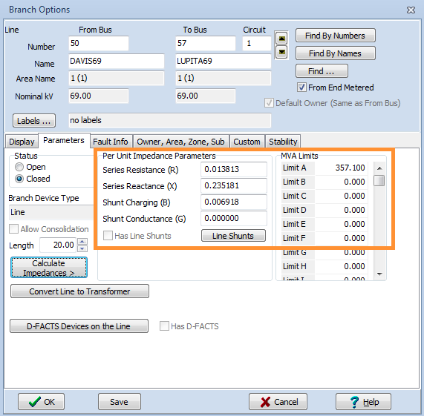

Figure 12: Parameters to Model a Subconductor Bundle of Three Cardinal Type Conductor Transmission Line

By running the model, power flow values and the power losses for the transmission line can be found.

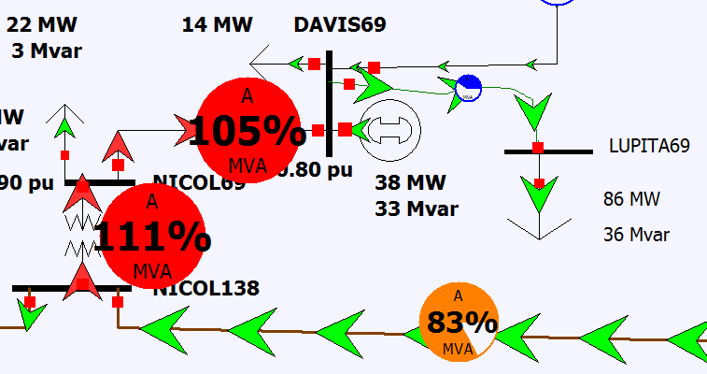

Figure 13: Model for Cardinal Transmission Line

As the model runs, a double click on the new transmission line will display the power flow and losses.

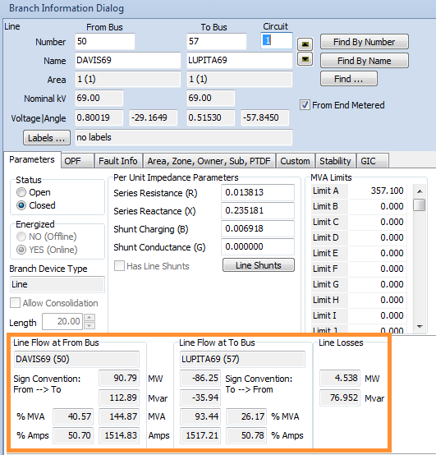

Figure 14: Cardinal Transmission Line Information

*Bluejay*

Using table A3, DS can be found for each conductor to calculate the geometric mean radius for each subconductor bundle.

DS Bluejay =0.0415’

GMRø = (DS x d x d)n/ (n^2) where n= number of conductors in each bundle.

GMRø = (0.0415 x 0.6 x 0.6)3/9 = 0.246’/ phase

With GMD and GMRø, L, C, XL, XC, R, Z, and Y can be found.

L = 0.7411 log (GMD/GMRø) mH/mile = 0.7411 log (25.2/0.246) mH/mile

L= 1.49 mH/ mi

C= 0.0388/ (log (GMD/ GMRø)) µF - mile = 0.0388/ (log (25.2/0.246)) µF - mile

C= 0.019299 µF – mi

XL = 2πƒ x L = 2 π * (60) * (0.00149)

XL = 0.56 Ω / mi

XC = 1/ (2πƒ x C) = 1/ (2π * (60) * (0.000000019299))

XC = 0.137447 MΩ / mi

Because the line length is YYYY miles, then the following are true:

XL = 0.56 x 20 miles= 11.2 Ω

XC = 0.137447 x 20 miles = 2.74894 MΩ

Y = G + j B

Assuming that the shunt conductance, G, is zero, then:

Y= j B

Therefore,

Y= 1/ (XC)

Y= 7.27553 µmho/ mi

R can be found from table A3:

R = 0.0861 Ω/mi at 20ºC for one conductor

Because the sub-conductor bundles have three conductors, the total resistance is reduced as their resistance is paralleled.

R= (1/0.0861+ 1/0.0861 + 1/0.0861)-1 = 0.0287 Ω/mi

Because the line length is 20 miles, then:

R= 0.0287 * 20 miles = 0.574 Ω

PowerWorld allows users to enter the parameters in actual values and performs per unit conversions using user-defined base values. In this case, the base values are 100 MVA and a base voltage of 69 kV

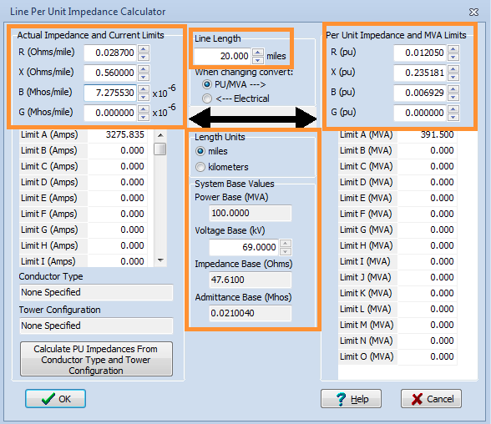

Figure 15: Impedance Conversion Values

MVA limits for this line must be found.

MVA = VLL I = * (69,000) * 3276 A

MVA = 391.5 MVA

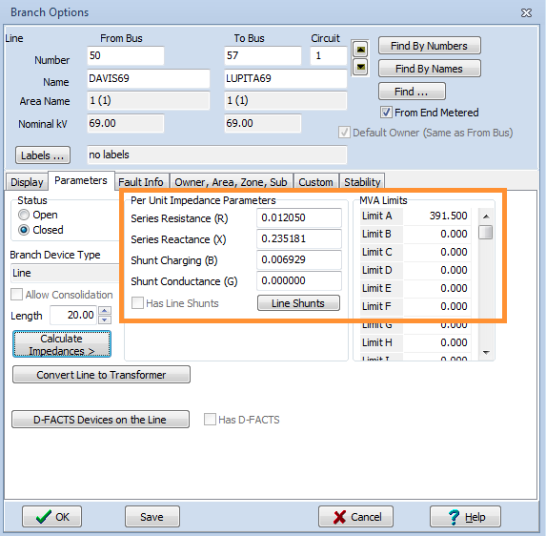

Figure 16: Parameters to Model a Subconductor Bundle of Three Bluejay Type Conductor Transmission Line

By running the model, power flow values and the power losses for the transmission line can be found.

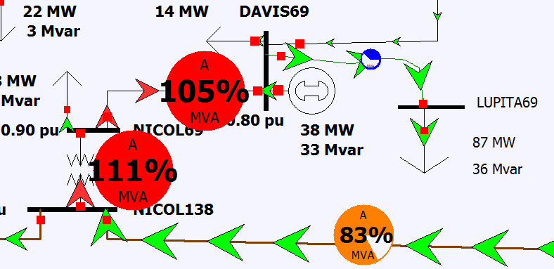

Figure 17: Model for Bluejay Transmission Line

As the model runs, a double click on the new transmission line will display the power flow and losses.

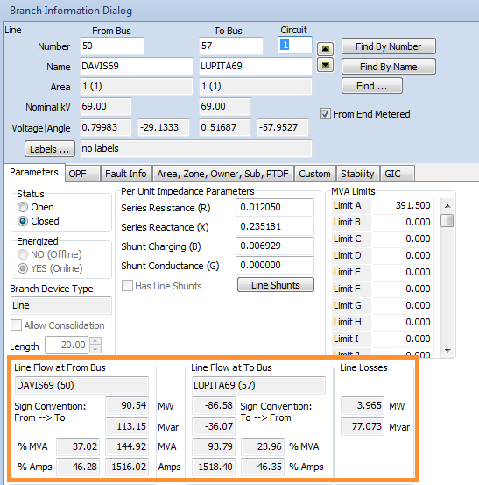

Figure 18: Bluejay Transmission Line Information

**Results**

|  |  |  |  |
| --- | --- | --- | --- |
| Parameter | Ostrich | Cardinal | Bluejay |
| Loading | 81.1% | 41% | 37% |
| MW Losses | 13.5 | 4.5 | 3.97 |
| MVAR Losses | 76.4 | 79.95 | 77.07 |
| Line Current | 1483 A | 1515 A | 1516 A |
| Line End Voltage  Bus LUPITA69 Voltage | 33.22 kV  0.48 pu | 35.56 kV  0.52 pu | 35.66 kV  0.52 pu |
| Cost | highest | high | lowest |

PowerWorld shows that the sub-conductor bundle of three Ostrich conductor transmission line operates at normal conditions with 81.1% loading. The power losses are 13.5 MW and 76.4 MVAR. These losses cause the voltage to drop at the bus LUPITA69 that reached to 33.22 kV (0.48 pu). From previous step, the Ostrich transmission line was capable of transferring 1476 A at normal conditions but is currently transferring 1483 A. Because of the losses, more current is transferred to supply the load requirements. Therefore, this is not a feasible option to supply the new substation load because it will overheat the transmission line insulation in long term because it is transferring more current than its rating. It can cause damage to equipment and it will have to be replaced.

PowerWorld shows that the sub-conductor bundle of three Cardinal conductor transmission line operates at normal conditions with 41% loading. The power losses are 4.5 MW and 79.95 MVAR. These losses cause the voltage to drop at the bus LUPITA69 that reached to 35.56 kV (0.52 pu). From previous step, the Cardinal transmission line was capable of transferring 2988 A at normal conditions but is currently transferring 1515 A. Because of the losses, more current is transferred to supply the load requirements. Therefore, this is a feasible option to supply the new substation load

PowerWorld shows that the sub-conductor bundle of three Bluejay conductor transmission line operates at normal conditions with 37% loading. The power losses are 3.97 MW and 77.07 MVAR. These losses cause the voltage to drop at the bus LUPITA69 that reached to 35.66 kV (0.52 pu). From previous step, the Bluejay transmission line was capable of transferring 3276 A at normal conditions but is currently transferring 1516 A. Because of the losses, more current is transferred to supply the load requirements. Therefore, this is another feasible option to supply the new substation load

Ostrich type conductors cannot be used because they will overheat and cause damage to the insulation. The transmission line will have a shorter life and it will have to be replaced more often. In addition, the Ostrich type conductor has the highest price. For the other two types of conductors, there are no significant differences in loading nor losses. Additionally, the voltage profile is nearly identical for these. Finally, both can accommodate future load demand increase. Nonetheless, because Bluejay conductors are less expensive than Cardinal conductors, the former option becomes the most suitable.

**Discussion**

The existing problem was modified into a more complicated and challenging version of it. In doing so, PowerWorld was of vital necessity to find the transmission line loading, losses, and voltage profile of the new bus. Thereafter, the best alternative was chosen based on the information provided. In a real-world example, choosing the configuration for a transmission line and the type of conductor used is a much more complex process that requires other software to help select the best option. Nonetheless, even with the limitations of PowerWorld, the tool was essential in finding the best available option from those contemplated.

**References**

American Wire Group (AWG) - http://wire.buyawg.com